**Wireless power transfer**

AIM: To Design a Low Distortion Wireless Power Transfer System.

Perquisite Questions:

1. What is the TX Device?
2. What is the RX Device?
3. What is the Speed we are going to Transmit?
4. What is the Range?
5. What kind of DATA Transfer?
6. What is the major use of the system?
7. Parameters Contributing to the system?
8. Analysis metrics?

PROPOSING BLOCK DIAGRAM:

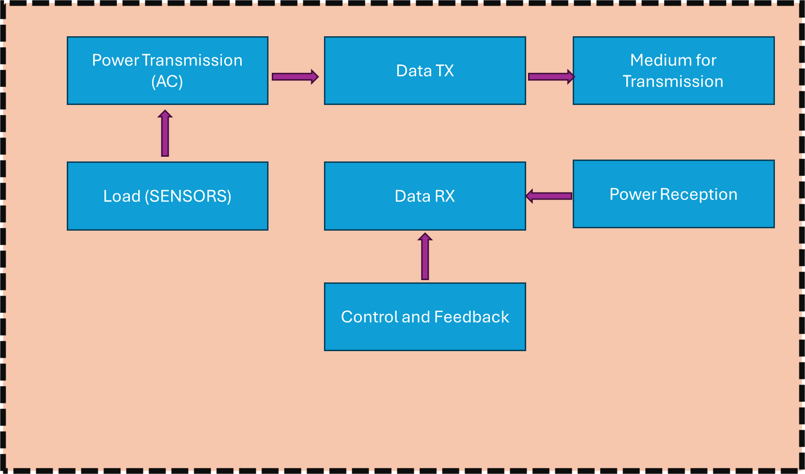

1. **POWER TRANSMISSION:**

* Power Source Selection (AC signal processing characteristics)
* Power Electronics Implementation (Step up / Step down the AC power)
* Transmitter Coil Design
* Modulation and Signal Mixing
* Protection Mechanisms (Feedback Mechanism)

1. **DATA TX:**

* Data Signal Generation
* Modulation Techniques
* Signal Processing
* Transmission Medium
* Transmitter Design
* Synchronization and Timing

1. Transmitter Coil Design:

* Coil Material Selection
* Coil Geometry Optimization
* Resonant Frequency Tuning
* Magnetic Coupling Maximization
* Inductance Calculation
* Thermal Management
* Shielding and EMI Reduction

And Vice Versa For Demodulation.

Coverage of the System:

The distance between the **transmitter (TX)** and **receiver (RX)** in a wireless power transfer (WPT) system depends on the transfer method used and the design requirements:

1. **Inductive Coupling:**

Typically effective for **short distances**, usually up to **a few centimeters** (e.g., 1–5 cm).

Commonly used in wireless chargers for devices like smartphones or electric toothbrushes.

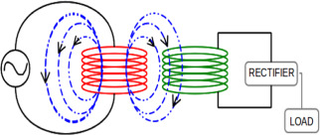

“Relies on magnetic fields between coils for power transfer, where energy is directly transferred via electromagnetic induction.”

* Lower operating frequencies (20-150 kHz)
* Used in short-distance applications like wireless chargers for phones, toothbrushes, and RFID systems.

1. **Resonant Inductive Coupling:**

Can achieve **greater distances**, typically in the range of **10 cm to 1 meter**.

Utilizes resonant circuits to transfer power over larger distances compared to direct inductive coupling.

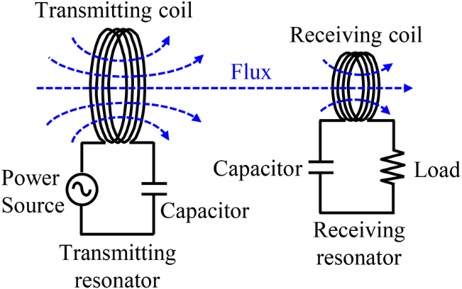

“Uses magnetic resonance, where both the transmitter (TX) and receiver (RX) coils are tuned to resonate at the same frequency, enhancing energy transfer.”

* higher frequencies (1-10 MHz)
* Used in medium-range applications like electric vehicle (EV) charging, medical implants, and industrial systems.

1. **Magnetic Resonance:**

Can transfer power over **moderate distances**, generally **1 meter to a few meters**, with high efficiency.

Typically used for applications like electric vehicle (EV) charging.

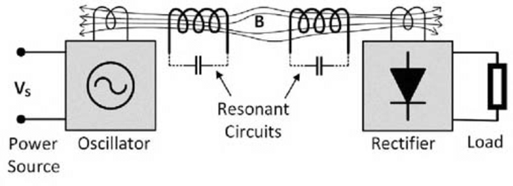

<https://www.researchgate.net/figure/Magnetic-resonant-coupling-method_fig3_349159930>

1. **Microwave or RF-based Transfer:**

Allows for **long-distance power transfer**, ranging from **a few meters to several kilometers**.

Mostly used in niche applications like satellite power transfer or powering remote sensors.

<http://www.inase.org/library/2015/zakynthos/bypaper/CIRCUITS/CIRCUITS-18.pdf>

TRANSFORMERS:

Electrical transformers are devices that transfer electrical energy between two or more circuits through electromagnetic induction.

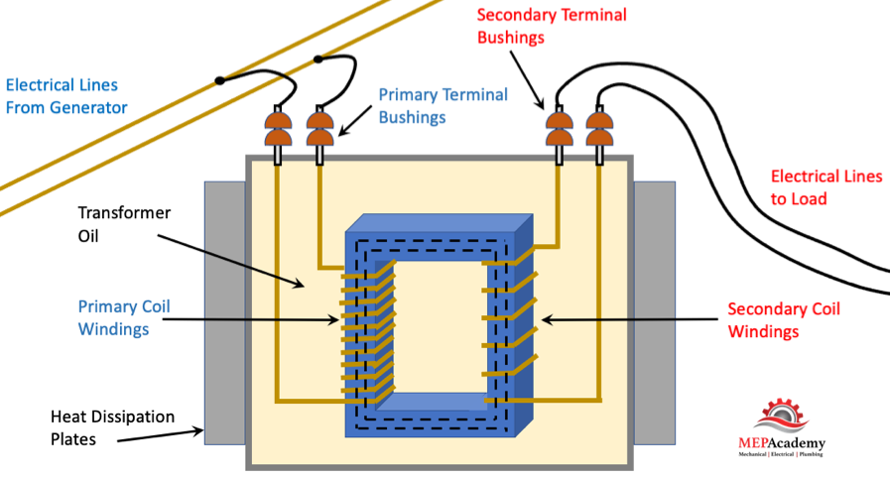

<https://mepacademy.com/wp-content/uploads/2022/07/Electrical_Transformer-construction.png>

Transformer types:

| **Category** | **Transformer Type** | **Description** |
| --- | --- | --- |
| Power Distribution | Laminated core | Most common type used in power transmission and appliances |
| Power Distribution | Toroidal | Donut-shaped, space-saving design with lower external magnetic field |
| Power Distribution | Autotransformer | Single winding tapped at some point, used for voltage adaptation |
| Power Distribution | Variable autotransformer | Autotransformer with adjustable turns ratio for voltage adjustment |
| Power Distribution | Induction regulator | Similar to wound-rotor induction motor, used for voltage regulation |
| Power Distribution | Polyphase | Used in three-phase power systems |
| Power Distribution | Grounding transformer | Provides a return path for current in delta systems |
| Power Distribution | Phase-shifting transformer | Adjusts phase relationship between input and output |
| Power Distribution | Variable-frequency transformer | Allows phase adjustment between asynchronous grids |
| Power Distribution | Leakage transformer | Has higher leakage inductance, used for current limitation |
| Power Distribution | Constant voltage transformer | Automatically maintains constant secondary voltage |
| Power Electronics | Ferrite core | Used in switched-mode power supplies |
| Power Electronics | Planar transformer | Uses flat copper sheets or PCB spirals as windings |
| Specialized | Liquid-cooled transformer | Large transformers with oil-immersed core and coils |
| Specialized | Cast resin transformer | Windings encased in epoxy resin for dry installation |
| Specialized | Isolating transformer | Provides galvanic isolation between circuits |
| Specialized | Solid-state transformer | Power converter that performs transformer functions |
| Instrumentation | Current transformer (CT) | Measures current in power systems |
| Instrumentation | Voltage transformer (VT) | Measures voltage in high-voltage circuits |
| Instrumentation | Combined instrument transformer | Integrates CT and VT in one unit |
| Signal Processing | Pulse transformer | Optimized for transmitting rectangular electrical pulses |
| Radio Frequency | Air-core transformer | Used for very high frequency work |
| Radio Frequency | Ferrite-core transformer | Used in RF applications, especially for impedance matching |
| Radio Frequency | Choke transformer | Made from windings of transmission line for wide bandwidth |
| Radio Frequency | Line section transformer | Uses transmission line sections for impedance matching |
| Radio Frequency | Balun | Connects balanced and unbalanced circuits |
| Radio Frequency | IF transformer | Used in intermediate frequency stages of radio receivers |
| Other | Transactor | Combination of transformer and reactor |
| Other | Hedgehog transformer | Homemade audio interstage coupling transformer |
| Other | Variometer and variocoupler | Variable inductors used in early radio receivers |
| Other | Rotary transformer | Couples signals between rotating parts |
| Other | Variable differential transformer | Non-contact position sensor |
| Other | Resolver and synchro | Rotary position sensors |
| Other | Piezoelectric transformer | Uses mechanically coupled piezoelectric transducers |
| Other | Flyback transformer | High-voltage, high-frequency transformer used in CRTs |

| Time Period | Technology | Applications | Key Developments |
| --- | --- | --- | --- |
| Before 1950s | Vacuum Tubes | Computers, radios, transmitters, high-fidelity sound systems | Ubiquitous in electronics, foundational technology |
| Post-WWII | Transistors & Solid-State Devices | Low power and low frequency applications | Transistor perfected; solid-state technology gains traction |
| 1950s-1970s | Transition Phase | General electronics, consumer devices | Initial belief that solid-state would replace vacuum tubes |
| 1970s-Present | Continued Use of Vacuum Tubes | High-power applications (radio transmitters, radar, electronic warfare) | Electron tubes remain dominant at high power and frequency |
| 1980s-Present | Advancements in Vacuum Tubes | Microwave communications, deep-space radar | Enhanced modeling, new materials improve efficiency and performance |
| 1990s-Present | Modern Vacuum Tube Technology | Specialized applications requiring high power | Bandwidth doubled, efficiency up to 75% in some devices |
| Present | Hybrid Technology | Advanced communications and scientific applications | Continued innovation in both vacuum tubes and solid-state devices |

**Electron Tube:**

“An electron tube is a device typically consisting of a sealed glass or metal-ceramic enclosure used in electronic circuits to control the flow of electrons.

Common applications of electron tubes include:

* Amplification: Boosting weak electrical signals.
* Rectification: Converting alternating current (AC) to direct current (DC).
* Generation: Producing oscillating radio-frequency (RF) power for radio and radar systems.
* Imaging: Creating images on television screens and computer monitors.

**Common Types of Electron Tubes:**

1. **Magnetrons**: Used in microwave generation. (Frequencies: 2.4 GHz to 10 GHz; Power: 10 W to several kW)
2. **Klystrons**: Employed in high-frequency amplification. (Frequencies: 1 GHz to over 40 GHz; Power: 1 W to several MW)
3. **Gyrotrons**: Designed for high-power microwave applications. (Frequencies: 20 GHz to over 300 GHz; Power: up to several MW)
4. **Cathode-Ray Tubes (CRT)**: Utilized in older television and monitor displays. (Frequencies: DC to several MHz; Power: typically, a few watts)
5. **Photoelectric Cells (Phototubes)**: Convert light to electrical current. (Wavelength: UV to visible light; Power: typically, in micro- to milli-watts)
6. **Neon and Fluorescent Lamps**: Emit light through gas discharge. (Operating Voltage: 90 to 120 V; Power: a few watts to several hundred watts)

“After 1890, inventor [Nikola Tesla](https://en.wikipedia.org/wiki/Nikola_Tesla) experimented with transmitting power by inductive and capacitive coupling using spark-excited [radio frequency](https://en.wikipedia.org/wiki/Radio_frequency) [resonant transformers](https://en.wikipedia.org/wiki/Resonant_transformer), now called [Tesla coils](https://en.wikipedia.org/wiki/Tesla_coil), which generated high AC voltages”

[GEISSLER TUBES](https://en.wikipedia.org/wiki/Geissler_tube) EXPERIMENT:

{ Early on he attempted to develop a wireless lighting system based on [near-field](https://en.wikipedia.org/wiki/Near_and_far_field) inductive and capacitive coupling[[35]](https://en.wikipedia.org/wiki/Wireless_power_transfer#cite_note-LeeZhongHui-35) and conducted a series of public demonstrations where he lit [Geissler tubes](https://en.wikipedia.org/wiki/Geissler_tube) and even incandescent light bulbs from across a stage.}

A **Geissler tube** is a precursor to modern [gas discharge tubes](https://en.wikipedia.org/wiki/Gas_discharge_tube), demonstrating the principles of electrical [glow discharge](https://en.wikipedia.org/wiki/Glow_discharge), akin to contemporary [neon lights](https://en.wikipedia.org/wiki/Neon_lighting), and central to the discovery of the [electron](https://en.wikipedia.org/wiki/Electron).

**Applying Voltage**: When the power supply is activated, a high voltage is applied across the electrodes.

**Ionization**: The high voltage ionizes the gas inside the tube, creating a path for electric current to flow.

**Discharge**: As electrons collide with gas atoms, they excite the atoms, leading to the emission of light when the atoms return to their ground state. This results in a colourful glow inside the tube.

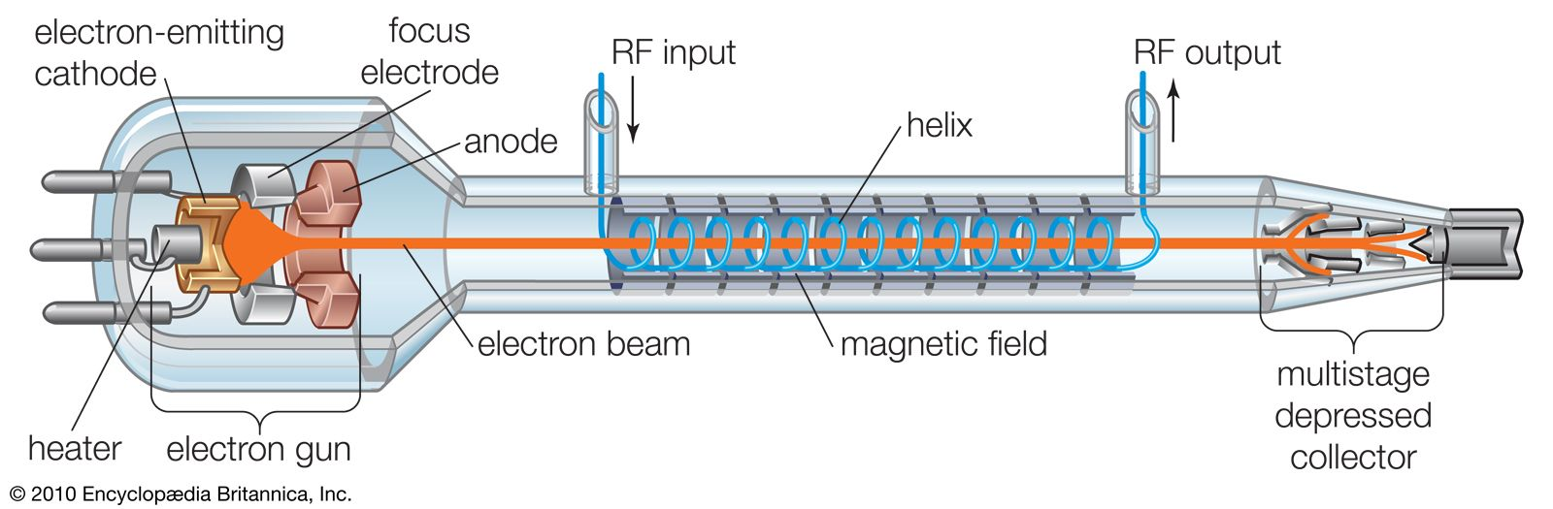

**Vacuum Tube:**

**“A vacuum tube  is a device that controls**[**electric current**](https://en.wikipedia.org/wiki/Electric_current)**flow in a high**[**vacuum**](https://en.wikipedia.org/wiki/Vacuum)**between**[**electrodes**](https://en.wikipedia.org/wiki/Electrode)**to which an electric**[**potential difference**](https://en.wikipedia.org/wiki/Voltage)**has been applied.”**

| **Aspect** | **Description** |
| --- | --- |
| **Types of Electron Tubes** | Thermionic tubes (thermionic valves) and non-thermionic tubes (e.g., vacuum phototubes) |
| **Function of Thermionic Tubes** | Utilize thermionic emission for signal amplification and current rectification |
| **Function of Non-Thermionic Tubes** | Achieve electron emission via the photoelectric effect for light detection |
| **Basic Structure** | Consist of electrodes with a heated cathode (thermionic) or ionized gas (non-thermionic) |
| **Simplest Form** | Diode (Fleming valve): Contains a heated cathode and an anode; allows unidirectional current flow |
| **More Complex Types** | Triodes (with control grids for modulation) and other multi-electrode devices (tetrodes, pentodes, etc.) |
| **Historical Significance** | Key components in radio, television, radar, sound recording, and early computers in the first half of the 20th century |
| **Replacement by Semiconductors** | Transistors emerged in the 1940s, offering smaller, safer, and more efficient alternatives |
| **Current Applications** | Used in magnetrons (microwave ovens), high-end audio amplifiers, and guitar amplifiers for "warmer" sound |
| **Classification** | - By number of electrodes (diode, triode, etc.)  - By frequency range (audio, radio, etc.)  - By power rating  - By application (receiving, transmitting, etc.)  - Specialized functions (e.g., CRTs, X-ray tubes) |